2-3 Milestone One: Project Proposal
Anthony Ashcroft
Southern New Hampshire University
CS330 – Comp Graphic and Visualization

2-3 Milestone One: Project Proposal
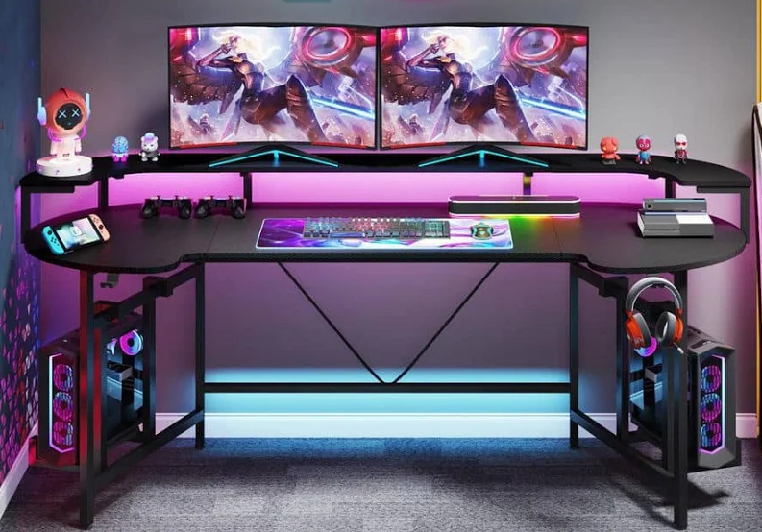
For project one, I will be replicating this computer desk in 3D. In the scene, I will attempt to duplicate both monitors, one of the computers, the keyboard, the mouse, the Xbox, the headphones, and the desk itself. I believe that these items will be a good choice as they provide the bulk of the setup and display good use of shapes to show my growth for the project. This will also help me to learn how to arrange shapes that use multiple objects to create complex objects.
To replicate the monitors, boxes will be used for the monitor itself. A plane can be used to show the screen of the monitor. Pyramids can be used as the stands for each monitor. This is a good choice as there are minimal changes needed to the basic shapes to achieve the look. The keyboard can also be created using a box. The mouse can be created using a cylinder that is made flatter. They will be sitting on a plane for the mouse mat to distinguish the separation from the desk. The Xbox can also be made from boxes, but this will test my ability to use multiple boxes combined to create one item. The headphones will be made from a torus for each ear and a half torus for the piece that sits on the head. I feel like this will be good practice as we do not always use the entirety of a shape in real life, so it is important to know how to cut something apart.
The desk will be the hardest part of this project. It contains multiple different shapes that will combine to make a full desk. This is also the most important piece as it is the focal point of the image. Each of the legs and supports for the desk will be designed using boxes. The left and right ends of the desk will be created using cones flattened to look like half-moons. The center of the desk will be created using either a plane or a box to fill out the entirety of the desk when connected to the ends. The top portion of the desk will be difficult as it is a single piece that is curved. I believe that this can also be created using a box or plane, and the rounded ends will be created by multiple boxes of different sizes or multiple triangles connected to give the illusion that it is rounded. This will all rest on the carpet that will be the plane that the desk and all other objects use to determine elevation of each object.

